ZH,
REPORT OF JOINT INVESTIGATION VISIT BY NOSDRA, SPDC, RIVERS STATE MINISTRY OF ENVIRONMENT AND BONNY COMMUNITY REPRESENTATIVES AT BONNY OIL AND GAS TERMINAL TANK 9 (NINE) STORAGE @ BONNY IN BONNY L.G.A OF RIVERS STATE.
INTRODUCTION
Acting on your directives on the SPDC request, a Joint Investigation Visit (JIV) was conducted at the Bonny Oil and Gas Terminal Tank 9 (NINE) Storage in Bonny L.G.A of Rivers State on the 13th of April, 2017 at about 12:10Hrs. This was a follow-up to the first visit of 7th April, 2017; where the Agency was not invited. The investigation was completed successfully on the same day. This report provides details.
INCIDENT PARTICULARS: 2017_ 1826306
FACILITY AFFECTED: BONNY OIL AND GAS TERMINAL TANK 9 (NINE) STORAGE @ BONNY IN RIVERS STATE.
DATE OF SPILL: 25/03/2017
DATE OF INSPECTION: 13/04/2017
CAUSE OF SPILL: EQUIPMENT FAILURE (Leak/Seepage around the Tank Foundation Shoulder and the Annular Plates see Fig.1a & b)
QUANTITY OF CRUDE OIL SPILLED: 569.37bbls (Approximately 570bbls)
SPILL POINT COORDINATES: N 04^{O} 25’ 47.03’’
E 007^{O} 09’ 42.55”
NATURE OF IMPACT: Heavy
INVESTIGATION TEAM:
- Koms Abam NOSDRA
- Okuese Ohis SPDC
- Chinedum Oji SPDC
- Ibitoru Dasu RIVERS STATE MINISTRY OF ENVIRONMENT
- Sidney Sunju Allison BONNY COMMUNITY (BECC)
OBSERVATIONS:
- On arrival to the Spill Area by the Joint Investigation Team (JIT), the Terminal Operators explained that, Tank 9 (Nine) has been out of service and was due for rehabilitation for the past Five (5) years, but due to financial constraints as explained my Management that could not be done. On the 25th of March 2017 they observed Crude seepage around the Tank Foundation Shoulder, just within the Annular Plates. (See Fig. 1a & b). Initially they wanted to handle the incident as LOPC – “Loss of Primary Containment”.
- They further explained that, the “RESIDUAL” Crude content in the Tank before the Leak was 25,321.00 Barrels, though the Total capacity of the Tank was not given at the time of JIV. Water was introduced to the Tank to assist with “Controlled Recovery/Evacuation” of the remaining Crude in the Tank. At the end of the operation 24,752.00 Barrels were recovered.
- The Spill Occurred within SPDC Right of Way – ROW (Tank) though it escalated beyond the Primary (1ºry) containment measure put in place to the Secondary (2ºry) containment (The Bund Wall) Area. (See Fig. 2a & b).
- The Impact covered a Total Area of 1.02HA with a Volume of approximately 570 Barrels of Crude Oil lost to the Environment by infiltration into the Laterite (Soil Type – Effective porosity of 20%) and Evaporation, with Free Phase Oil observed/enclosed within the Bund Wall. (See Fig. 3a & b). Measurements were taken within the Pit (0.8M) and the Drainage (0.4M + 0.3M + 0.1M), which gave us a Total Depth of 1.6M and an Average Depth of 0.4M (i.e. 1.6M divided by 4).

IMPACTED AREA COORDINATES:
- N 04^{O} 25’ 46.09’’ 2. N 04^{O} 25’ 45.85’’ 3. N 04^{O} 25’ 49.12’’
E 007^{O} 09’ 42.25” E 007^{O} 09’ 42.60” E 007^{O} 09’ 41.40”
4. N 04^{O} 25’ 47.17’’ 5. N 04^{O} 25’ 46.54’’ 6. N 04^{O} 25’ 46.30’’
E 007^{O} 09’ 44.04” E 007^{O} 09’ 42.58” E 007^{O} 09’ 42.93’’
7. N 04^{O} 25’ 44.51’’ 8. N 04^{O} 25’ 46.88’’ 9. N 04^{O} 25’ 46.31’’
E 007^{O} 09’ 42.07” E 007^{O} 09’ 39.78” E 007^{O} 09’ 39.38”
10. N 04^{O} 25’ 46.45’’ 11. N 04^{O} 25’ 47.46’’ 12. N 04^{O} 25’ 47.53’’
E 007^{O} 09’ 40.61” E 007^{O} 09’ 41.01” E 007^{O} 09’ 40.50”
13. N 04^{O} 25’ 49.18’’ 14. N 04^{O} 25’ 44.20’’ 15. N 04^{O} 25’ 44.42’’
E 007^{O} 09’ 41.40” E 007^{O} 09’ 44.10” E 007^{O} 09’ 42.08”
16. N 04^{O} 25’ 46.29’’
E 007^{O} 09’ 39.31”

RECOMMENDATIONS
- Repair work should be carried out and the area cleaned up.
CONCLUSION
The JIV was successful. This report is subject to your steer and further directives.
Koms Abam
SES
_____________________________
16th April, 2017
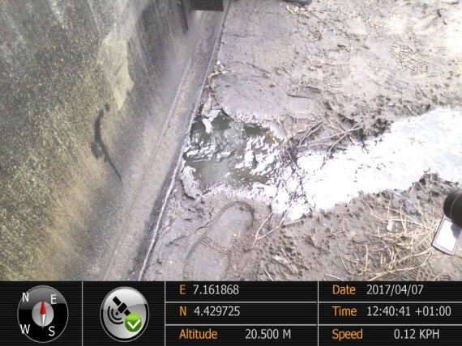 ` 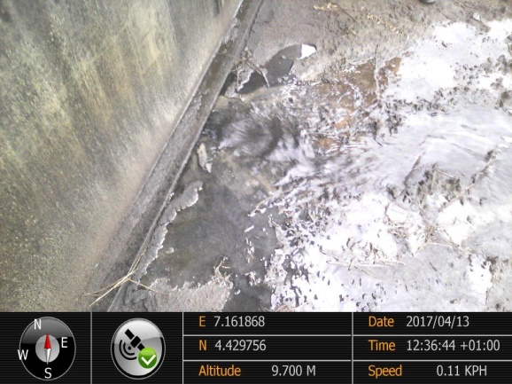
Fig. 1a Leak/Seepage (Foundation Shoulder) Fig.1b Around the Tank Annular Plate
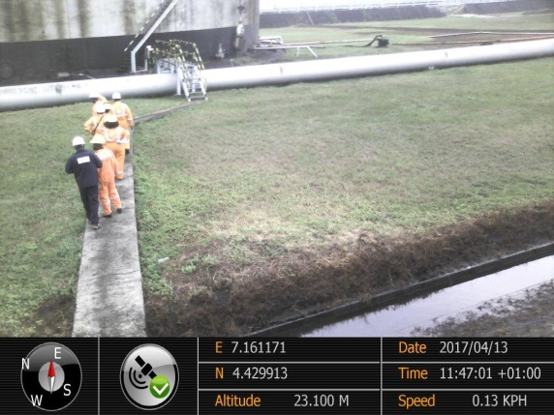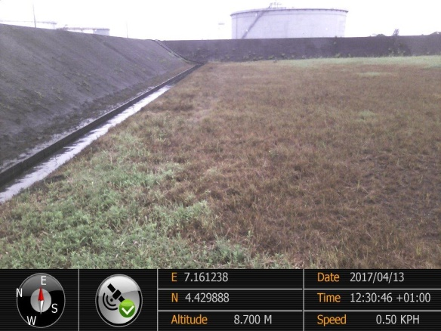
Fig. 2a Contained Crude within Bund wall Fig. 2b Impacted Grasses within Bund Wall
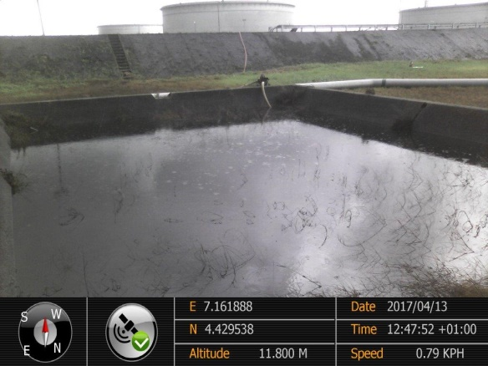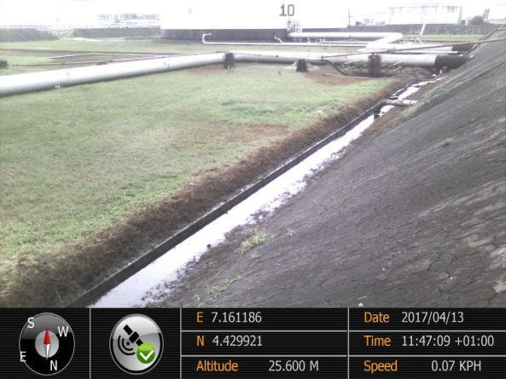
Fig. 3a Free Phase Oil in a Pit Fig. 3b Free Phase Oil along the Bund Wall

